**Oleksandra Albear Rodrihes Portfolio Projects**

**Portfolio Projects:**

Extreme Parkour

Granny Shooter

The Mystery of ItaKai

Depth47

**Extreme Parkour**

"Extreme Parkour" is a fast-paced third-person game in which players assume the role of a professional parkour athlete racing across skyscraper rooftops in a futuristic city. With just 60 seconds to reach a goal point, players navigate through urban obstacles using a variety of parkour moves.

The idea stemmed from my desire to explore a movement-based game that is exciting, replayable, and accessible. After developing a shooter in my previous project, I wanted to challenge myself with a more fluid, physics-based experience. I chose parkour because it blends dynamic animation, precise control, and visual appeal while providing a short, addictive challenge loop.

I developed the game using Unreal Engine 5, focusing heavily on importing and adapting high-quality character animations. This involved extensive experimentation and troubleshooting as I learned how to synchronize movement transitions with player input and environmental triggers.

I programmed 13 distinct player actions—like jumping, sliding, climbing, and crouching—all of which react to the player's surroundings. For instance:

* Jump animations change based on obstacle height
* Sliding fails on upward slopes
* Climbing only works when a ledge is detected

I conducted a short playtest to validate core mechanics and received great feedback about the character movement, which became the centerpiece of the game experience.

Alongside the animation system, I implemented a countdown timer with win/lose conditions, buttons to restart or exit the game, and a functional level design that includes skyscraper edges and obstacles.

The project was created in winter 2025. This was an individual project, created independently.

By the end of the development cycle, I had built a working prototype that reflected the core game loop and play experience I envisioned. Key outcomes include successful implementation of 13 reactive movement animations, a functioning 60-second challenge loop, a clear pathway for further development, including multiplayer and free-roam modes, and realistic planning for platform compatibility (Android, iOS, PC).

The biggest lesson was learning how time-consuming and technically complex animation integration can be. It pushed me to troubleshoot creatively and work iteratively. I also learned how important user feedback is, especially when working on something as tactile and visual as movement.

Looking ahead, I plan to expand the game with new modes and challenges, and continue building my portfolio with different genres.

[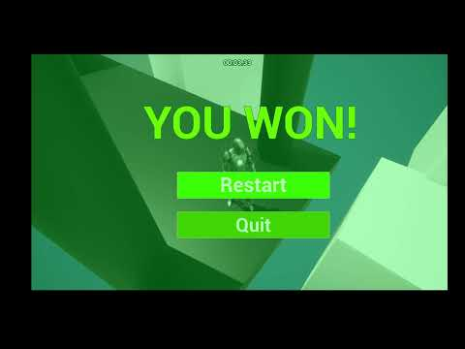](https://www.youtube.com/embed/YEnxnDtmSzc?feature=oembed)

**Granny Shooter**

*Granny Shooter* is a darkly comedic first-person shooter where players take on the role of a frustrated old woman who has had enough of the noisy, rude neighbors outside her Soviet-style apartment. Armed with a gun and just 20 seconds, players must shoot as many people as possible to rack up a high score. The game emphasizes simplicity, replayability, and a distinct post-Soviet aesthetic that particularly resonates with Eastern European audiences.

The idea for Granny Shooter came from a desire to combine humor with fast-paced action, using a setting familiar and nostalgic to many post-Soviet players. I wanted to experiment with character-driven storytelling in an ultra-short gameplay loop, similar to arcade-style shooters, but with a unique twist and cultural flavor.

The game was developed in Unreal Engine, and I handled all elements of the project, including character scripting, level layout, timing mechanics, and basic UI. Special attention was given to aesthetic details, such as the interior design, Soviet-era props (wall carpets, radios, condensed milk), and the exterior cityscape. During playtesting, I received feedback about visibility issues, HUD limitations, and the need to stop shooting when the timer ends — all of which I’ve started planning to implement in future updates.

This project was completed individually in autumn 2024 as part of the bootcamp assignments and personal portfolio work. Playtesting feedback came from peers, including testers from Eastern Europe, whose cultural familiarity with the theme greatly enriched the design reflection process.

Through the development of *Granny Shooter*, I successfully created a fully playable FPS prototype that effectively delivers a tight, 20-second gameplay loop. The core mechanics — time-limited shooting and a scoring system — were executed as planned and provided a strong foundation for the game’s fast-paced replayability. One of the most rewarding aspects of the project was the attention to environmental storytelling; the game’s post-Soviet visual style received enthusiastic responses, particularly from Eastern European playtesters who resonated with its cultural references and aesthetic choices.

The playtest phase offered valuable insights. Players appreciated the humor, tone, and simplicity, but also provided constructive suggestions that guided the next steps in development. From this, I learned the importance of clear visual communication, particularly with UI elements such as the aiming reticle and feedback on the timer’s functionality. I also realized how even simple mechanics benefit from polish and player guidance, such as adding a results screen or a basic tutorial.

Overall, the project helped me improve my technical skills in Unreal Engine, deepened my understanding of player psychology in short-form games, and showed me how humor and cultural specificity can enhance a game's charm. It was a fun, challenging, and creatively satisfying experience that expanded both my design thinking and production process.

[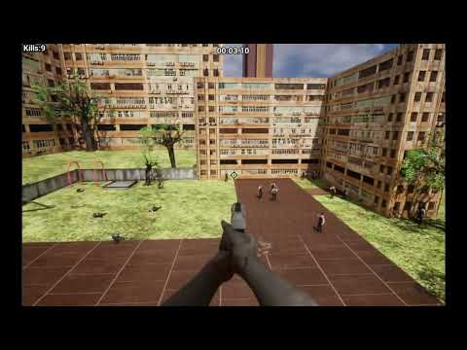](https://www.youtube.com/embed/p9CWE-se3JQ?feature=oembed)

**Situation:**

*Granny Shooter* was created as a fast-paced satire of noisy neighbors, drawn from a common trope in Eastern European culture. I wanted to combine humor and absurdity with tight gameplay in a 20-second challenge format. The visual tone of the game was a love letter to post-Soviet aesthetics, packed with cultural references and environmental storytelling.

**Task:**

My goal was to build a short yet compelling FPS game that could be replayed over and over, with satisfying mechanics and a clear identity. The pillars were simple: quick playtime, score tracking, and gunplay that feels rewarding from the start.

**Action:**

I developed the game solo using Unreal Engine. I scripted mechanics for a countdown timer, scoring system, and shooting logic. I designed a detailed environment based on a post-Soviet apartment and implemented one animated enemy type. During a live playtest, I gathered feedback on the UI, shooting mechanics, and environmental design. I then created a roadmap for future improvements, including UI polish, sound design, and adding multiple targets.

**Result:**

The game succeeded in grabbing player attention instantly with loud sound effects, flashing gunfire, falling targets, and short, intense sessions. Testers found the game fun and replayable, praising its humor and atmosphere. Feedback inspired several future updates: improved reticle, HUD elements, voice lines, and a tutorial screen. The project helped me refine my skills in game pacing, player feedback systems, and cultural storytelling, and solidified my interest in making games that blend humor with tight mechanics.

**The Mystery of ItaiKai**



*The Mystery of ItaiKai* is a third-person single-player action-adventure game set on a remote, nature-bound island where the protagonist, Wei Jiang, must master elemental forces and uncover ancient secrets to protect his people. The game blends narrative depth with engaging mechanics, including elemental magic, puzzle-solving, exploration, and a dramatic story of trust and betrayal.

I was inspired by the themes and atmosphere of *Grandmaster of Demonic Cultivation* and traditional Chinese dramas and wanted to create a game that immersed players in a story-driven experience filled with emotional complexity, nature-based power systems, and personal growth. I designed the project with a clear focus on building a world that felt real and alive, where nature is not just a background but a living force that players connect with.

I mapped out the island’s lore, narrative arcs, and gameplay progression. Combat is tied to each elemental force (wind, water, earth, fire), which are unlocked through meditation, mini-trials, and battles. Players also solve environmental puzzles, sneak through guardian challenges, and make choices that reflect moral values tied to the island’s harmony. I wrote a full story arc, quest structure, dialogue tone, and skill system, ensuring gameplay supports both narrative immersion and mechanical depth.

This is an individual project started in winter 2025, built as part of my bootcamp and portfolio. No external studio involvement, but inspired by extensive world-building research and playstyle analysis from titles like *Hogwarts Legacy* and *Uncharted 4*.

Working on *The Mystery of ItaiKai* helped me strengthen my worldbuilding, narrative design, and systems thinking. I built a rich cultural backdrop inspired by real traditions and fantasy influences, and aligned character development with gameplay mechanics. One major takeaway was how to connect player emotion with story events, especially the relationship between Wei Jiang and Lyeotolv. It taught me how betrayal, trust, and atmosphere can elevate a story's impact.

Another key outcome was developing a power acquisition system tied to environmental tasks and meditation, which pushed me to balance difficulty, story logic, and player progression. I also learned to plan branching interactions, moral choices, and side quests with long-term effects. This project challenged me to maintain consistency in tone, aesthetics, and gameplay pacing — all while ensuring the game remains interactive and rewarding throughout.

[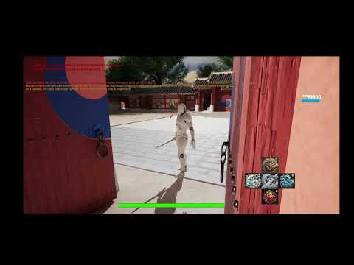](https://www.youtube.com/embed/wjwIQEwsyAQ?feature=oembed)

**Situation:**

I wanted to create a rich, story-driven action-adventure game that balances emotional storytelling, elemental combat, and world exploration. Inspired by Chinese folklore aesthetics and dramas, I conceptualized *The Mystery of ItaiKai*, a game centered on Wei Jiang — a young heir who must master the powers of nature and uncover ancient texts to protect a sacred secret.

**Task:**

The goal was to design a game where narrative, mechanics, and progression were all deeply intertwined. I wanted players to feel immersed in the island’s mystery, emotionally invested in the characters, and challenged by meaningful tasks like meditation, power trials, and morally complex decisions.

**Action:**

I created the entire lore, character arcs, skill systems, and gameplay loops. I mapped out four major gameplay phases, each centered on discovering new powers and advancing the story. I designed power acquisition tasks (tightrope balancing, breath control underwater, etc.), combat mechanics, environmental puzzles, stealth scenarios, and decision-based quests that reflect the island's values. I also planned a unique skill progression system based on both story events and optional side quests, ensuring player agency and reward.

**Result:**

The result is a compelling game blueprint with layered systems and narrative weight. I gained strong experience in weaving story with gameplay, building cultural authenticity into design, and balancing player freedom with structure. I now have a framework for a unique game with emotional stakes, atmospheric beauty, and strong potential appeal to both Eastern and Western audiences.

**Depth47**

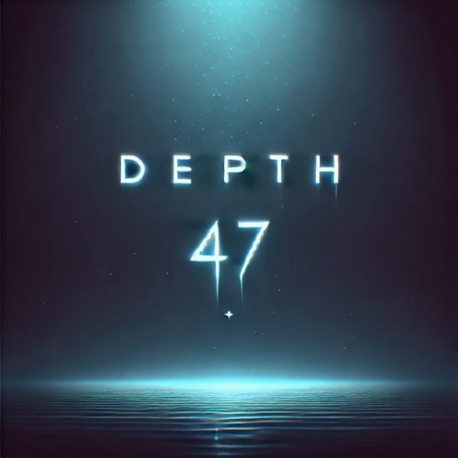

*Depth47* is a single-player, first-person psychological horror game where players take on the role of a grieving father who discovers the horrific truth behind his daughter’s suicide: a manipulative, real-life-inspired game that ends with the final task of self-harm. In a desperate search for justice, the father decides to play the game himself to lure the curator responsible for destroying his family.

This project was born out of a desire to create horror rooted not in fantasy, but in reality,psychology, and grief. I was inspired by disturbing real events from the 2010s involving dangerous online communities that targeted teenagers through manipulation and fear. The goal was to transform these themes into a narrative-driven game experience that raises awareness while delivering emotional impact through suspense, atmosphere, and moral choices.

I developed the concept around a story-first structure with minimal UI, tight environmental storytelling, and survival-focused mechanics. The gameplay centers around interactions with household objects and a mobile phone interface used to receive tasks from the curator. The project was carefully designed to avoid cliché horror tropes like excessive jump scares, instead focusing on subtle psychological tension, realistic pacing, and immersive audio design.

It was planned and documented in Winter 2025. *Depth47* is currently an individual narrative design and game concept project developed independently. Future plans include assembling a small team for full production (designer, programmer, sound designer, artist).

Designing *Depth47* allowed me to explore a deeper level of emotional storytelling through gameplay. I strengthened my skills in environmental storytelling, narrative structure, horror pacing, and emotional player engagement. By designing multiple endings, psychological task progression, and decision-driven gameplay, I learned how to build player agency within a linear story.

This project also sharpened my ability to plan a complete development pipeline — from storyboarding, task and lighting design, to survival mechanics and UI simplicity. I explored how audio design and minimal music can heighten player vulnerability and fear. Overall, this game concept taught me how to balance realism and horror, delivering tension through subtle narrative moments rather than traditional scare tactics.

**[](https://www.youtube.com/embed/SEVZyiOZFfo?feature=oembed)**

**[](https://www.youtube.com/embed/QwJWJHFuXx0?feature=oembed)**

**Situation:**

I set out to create a horror game that reflected real-world psychological dangers — something deeper than monsters or ghosts. *Depth47* follows a father whose daughter dies after playing a deadly online game. The only way to find her killer is to play the game himself. The player experiences his unraveling grief and obsession, completing disturbing tasks until a confrontation with the game’s manipulative curator.

**Task:**

The challenge was to design a **narrative-driven horror game** that delivers authentic tension and emotional weight. I aimed to avoid traditional horror clichés and instead immerse players in a believable, quiet terror built on loss, guilt, and escalating fear — all through the eyes of one devastated father.

**Action:**

I crafted a branching narrative with **four distinct endings**, built a day-night task progression system, and scripted increasing psychological pressure across three nights of gameplay. I designed the UI to be intentionally minimal — just a phone, a knife, and a car key — keeping the focus on immersion and emotional realism. Audio plays a central role: near-silence is used to heighten vulnerability, with sudden sound cues only in moments of real danger. I also laid out mechanics for task refusal and survival scenarios, making each decision impactful.

**Result:**

*Depth47* became a fully mapped-out psychological horror experience grounded in realism. It reflects real-world emotional trauma while giving players meaningful choices that affect the outcome. I deepened my understanding of emotional pacing, psychological mechanics, and how to use space, silence, and dread to engage players. The project also helped me refine a development timeline and team structure for future production. *Depth47* stands out as a haunting, intimate, and thought-provoking horror game that reflects my growth as a designer focused on narrative, emotion, and immersion.